FCD Scheme Information

Toolchain Overrides

Chip Details

Chip Configuration

Pins

ADC

DAC

I2C

I2S

PWM

SPI

Interrupts

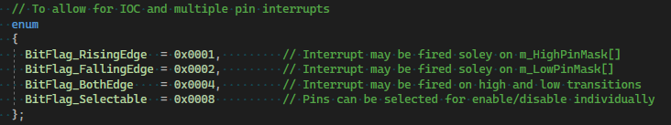
<ioc config=’0x0f’>

Code Generation

In Circuit Debug

